Project Design Phase-II Technology Stack (Architecture & Stack)

Date | 01 October 2026
Team ID | SWTID-2026-2085
Project Name | Import Data Using Transform Maps (Spreadsheet)
Maximum Marks | 4 Marks

The diagram above follows the guidelines in your template. The client runs locally in the browser, the server and database are cloud-hosted, and the data-storage components are shown separately. The flow is: the user works in the React UI, requests pass the auth middleware, the upload parser stages the spreadsheet rows, and the transform engine maps and validates them into the target records.

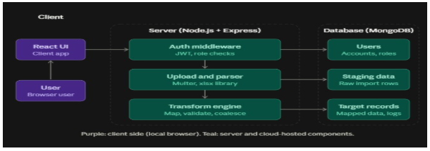

Table 1: Components & Technologies

S.N  o | Component |  | Description | Technology
1 | User Interface |  | Web UI for login, file upload, data preview, transform map editor, and import history | React.js, HTML, CSS, JavaScript
2 | Application Logic-1 |  | Authentication and authorization (JWT, role-based access) | Node.js, Express.js, bcrypt, jsonwebtoken
3 | Application Logic-2 |  | Spreadsheet upload and parsing (.xlsx / .csv) into staging | Multer, xlsx library
4 | Application Logic-3 | Transform engine: field mapping, validation, coalesce, insert/update |  | Node.js (JavaScript)
5 | Database | Stores users, transform maps, and import history |  | MongoDB, Mongoose
6 | Cloud Database | Hosted database service |  | MongoDB Atlas
7 | File Storage | Temporary storage of uploaded spreadsheet files |  | Local file system (server uploads/ folder) or cloud storage such as AWS S3
8 | External API-1 | Email/OTP confirmation and Gmail sign-in |  | Nodemailer or an OTP service, Google OAuth
9 | External API-2 | Not used [replace if you add one] |  | N/A
10 | Machine Learning Model | Not applicable; the project uses rule-based mapping, not ML |  | N/A
11 | Infrastructure (Local / Cloud) | Frontend and backend hosted on the cloud, with local development and testing |  | Render / Vercel / AWS, Git & GitHub, Postman

Table 2: Application Characteristics

S.N  o | Characteristic | Description | Technology
1 | Open-Source Frameworks | React, Express, Node.js, Mongoose, Multer, xlsx | MERN stack
2 | Security Implementations | Password hashing, JWT tokens,  role-based access control, file type and size validation, environment variables for secrets, HTTPS | bcrypt, JWT, CORS, Helmet, dotenv
3 | Scalable Architecture | Three-tier architecture (client, server, database) where each tier scales independently; background job queue for large imports | REST API,  MongoDB indexing, [optional: Bull/Redis]
4 | Availability | Cloud hosting with database backups for recovery | MongoDB Atlas, cloud hosting
5 | Performance | Batch inserts (bulkWrite), indexed  coalesce fields, and streaming for large files | Mongoose bulk operations, pagination

